

The Guys

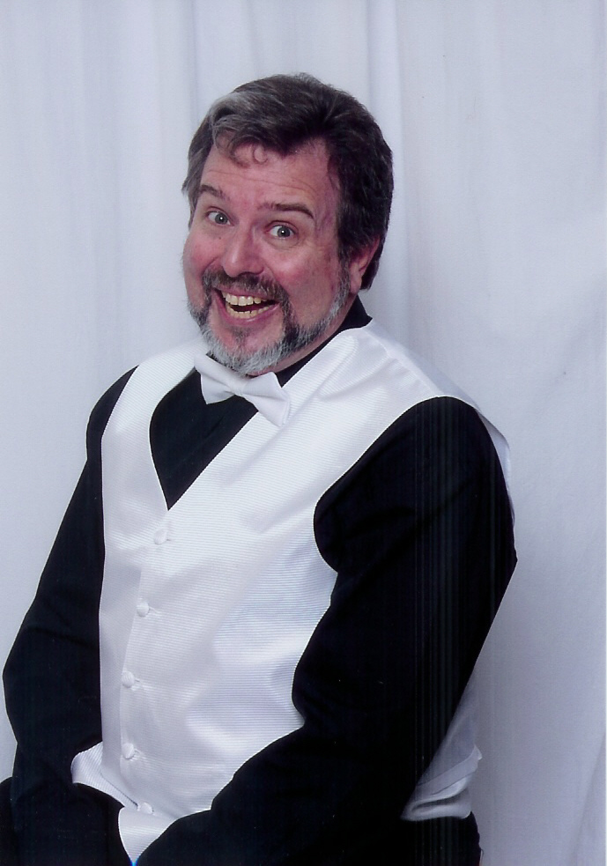 | Tenor, MATT PARSONS, has been a society member since 1979. He was invited to attend a guest night by the youngest son of the "Daniel Boone Chorus" now the "Ambassadors Of Harmony" Director who was Bob Henry at the time. Jim Henry was a very proud member and was eager to bring someone new in. He has sung with the Ambassadors of Harmony and The Singing Buckeyes but is currently not doing any active chorus singing. He has also picked up animation as his newest hobby and is using it to promote barbershop music between lessons as he's still learning. Being able to make anything sing barbershop is fun and a little bizarre, but hey, that's Matt in a nutshell. He has worked for the Defense Department and is now working for Veterans Affairs in accounting.
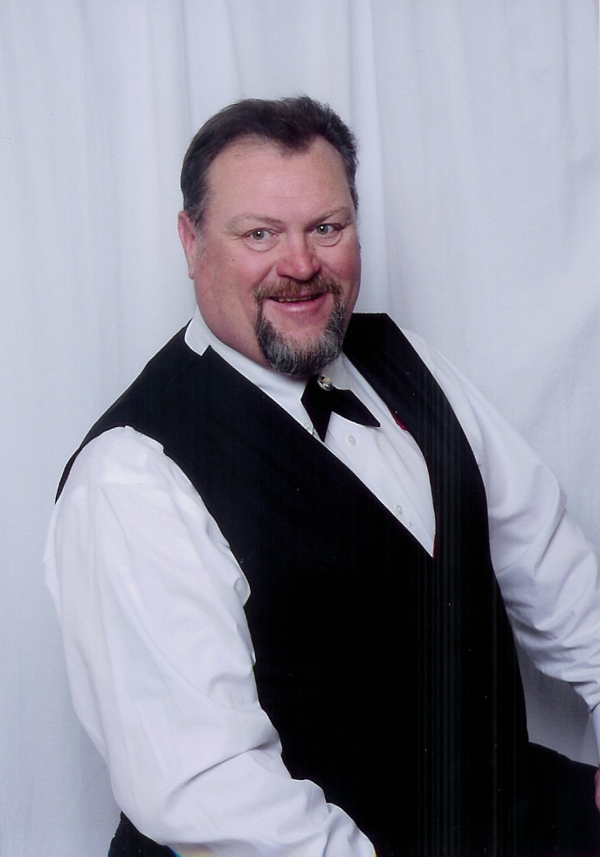 |  | Lead, MIKE DOHOGNE, started Barbershop around 1977 in Minot, ND. A member of his Church group talked to him and told him he would pick him up and bring him to the church to see another singing group. He went, sang, went to a show with the guest quartet "OK 4". He was hooked and has been singing ever since. He is one of the most active barbershoppers you will ever meet. He sings with the Belleville Sounds of Harmony chorus and the Florissant Valley Men of Harmony Chorus, where he is the current president. He is also active with another quartet, the Father & Son Reunion, where he sings with his son, brother-in law, and nephew, and he is also starting a senior quartet. Mike works for the railroad here in the St. Louis area when he's not actively singing.
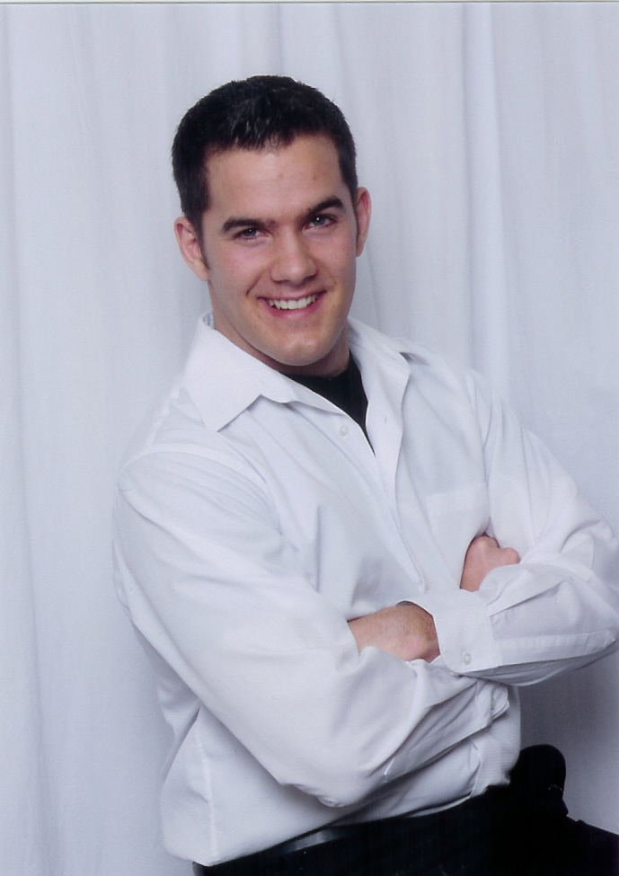 |  |  | Bass, BENJAMIN BURK, has been performing vocally since his freshman year of high school. He was 18 when he started singing barbershop with the High Mountain Chordsmen of Prescott, Arizona. Ben spent two years attending St. Cloud State University where he was part of the university men's choir and concert choir. While attending SCSU, Ben met his future wife Anna, who plays basketball for the University. He is currently serving in the Air Force as a Combat Correspondent on Scott Air Force Base, IL. Aside from music, He enjoys playing and watching sports. He is now continuing his in his love for barbershop harmony with Gateway Edition and the Sounds of Harmony, serving as the chorus’ current president.
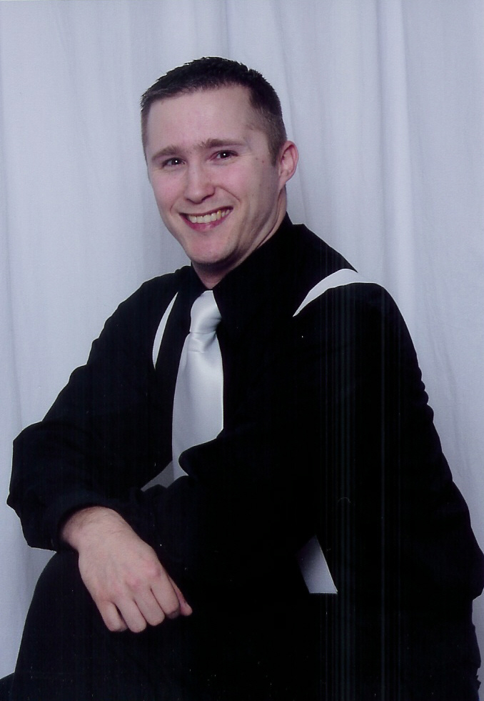 |  |  |  | Baritone, STEVE MARTIN, was a barbershopper from the moment he was born. He has been actively singing for 21 years of his life (yeah he doesn’t look that old, since the age of 10. He has sung with many quartets and choruses, and is presently active with the Belleville Sounds of Harmony chorus as the current Membership VP and Program VP. He currently serves as an active duty Staff Sergeant in the Air Force as a Computer Specialist.  http://www.harmonize.com/GatewayEdition  Gateway Edition  1837 Lebanon Ave. Apt. 7  Belleville, IL 62221

